**Raritan River Publishing**

FOR IMMEDIATE RELEASE Contact: Lisa Shenkle

Phone: 410-227-5899

Email: lshenkle@att.net

**Debut Author Wins National Gold Medal, International Acclaim for ‘Best Children’s Book’**

**An outcast girl looking to belong discovers a secret doorway to other realms in a thrilling portal fantasy novel for middle-grade readers.**

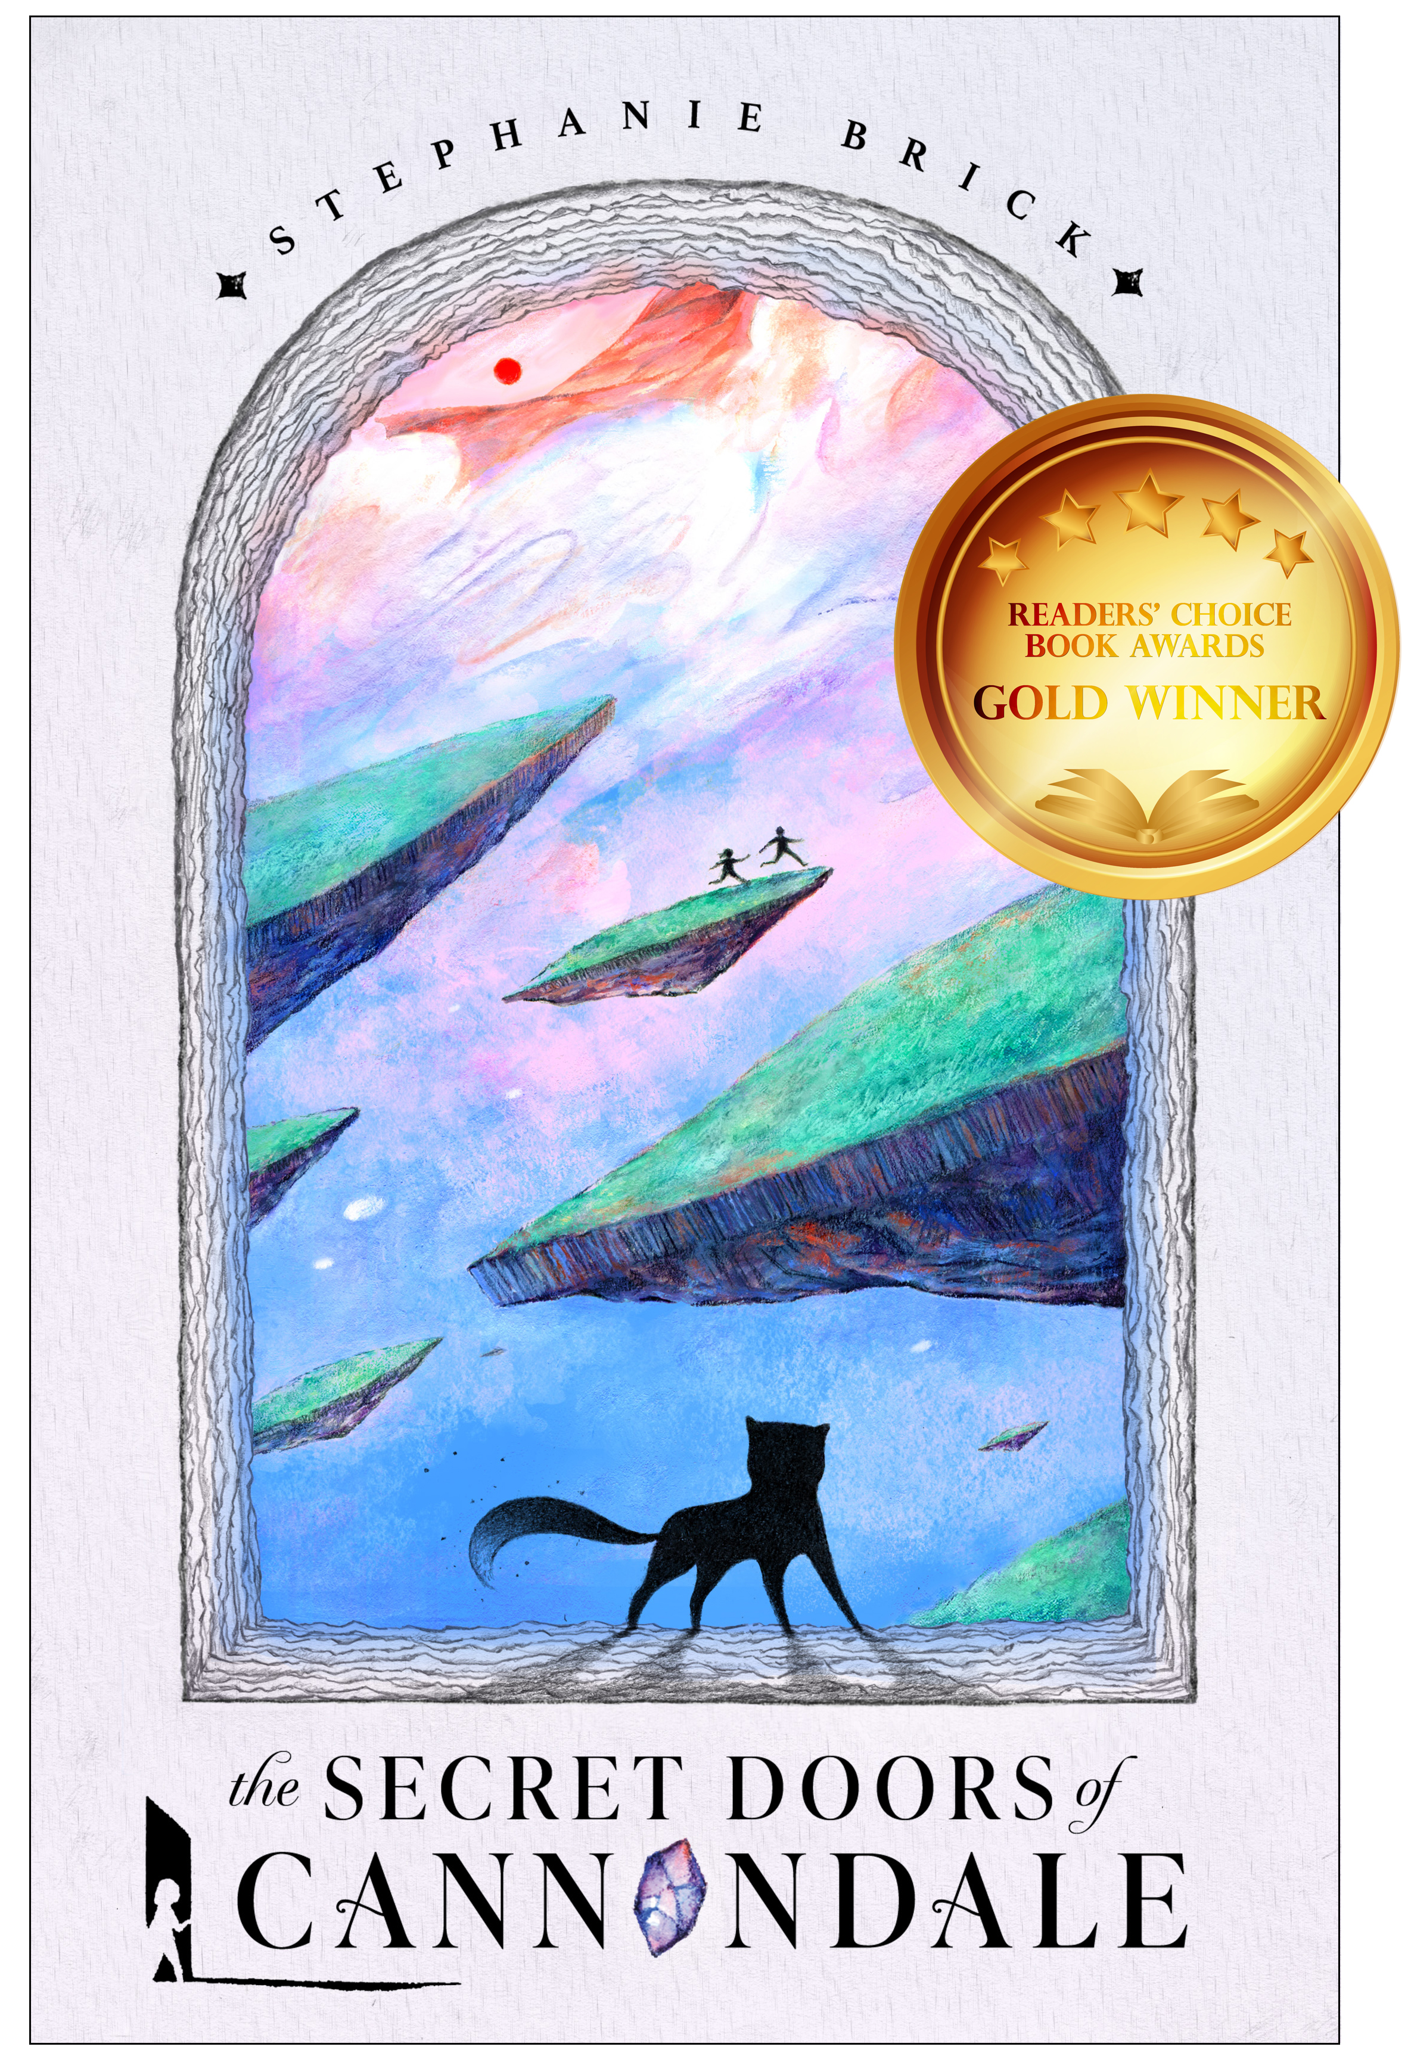**WASHINGTON, D.C.** – Debut novelist Stephanie Brick masterfully creates a story of belonging, self-discovery, and survival with her new middle-grade portal fantasy, *The Secret Doors of Cannondale*. Brick’s book, the first installment in a trilogy, was nationally awarded the gold medal for 2024 Best Children’s Book (ages 8 to 12) by Readers’ Choice Book Awards, and recently won honorable mentions in the international Purple Dragonfly Book Awards (Middle Grade Fiction, and New Author).

When twelve-year-old Adeline Perle’s transient family finally plants roots in an old, creaky house, the girl craves to build the lasting friendships she never had. She gets more than she bargained for when the house’s hidden door unveils a portal to another realm where she is confronted with creatures and unusual people, good and evil, and a new friend who’s desperate to help her find her way back home.

In Brick’s intriguing story, Adeline’s mother’s Navy job had them moving every three years, making the girl a constant outsider and forging friendships difficult. Adeline feels promise when their final move is to a house called Cannondale, an old and creaky place with hidden rooms, invisible wall panels, and secret doors. She’s exploring when she comes upon a camouflaged door behind which she finds a secret room with a curious box. What she finds inside will change Adeline’s whole world.

Adeline is thrilled when she meets an affable group of friendly teens at Cannondale who take to the girl immediately, including a sixteen-year-old boy named Gabriel. Finally feeling close to having the type of friendships she’s always sought, she decides to share with them the secret that she found in the unusual box. But before she gets the chance, Adeline is unknowingly thrust through a portal into extraordinary realms of magic, soaring stone islands, savage monsters, eccentric humans, placid worlds, and warring peoples of a once tranquil place called Nouvaal—one side led through deceit by a brutal and manipulative ruler bent on expropriating all magic for her own dark power, the other led by her twin sister, a kind and altruistic leader whose mission is to bring the Paeth and Nigh peoples back to peace and prosperity.

Adeline is astonished when it appears Gabriel has followed her through the portal to guard her from the very realm she’s ended up—Nouvaal, a place the boy seems to be well-acquainted with. Adeline is trapped, in danger for having discovered the long-hidden treasure that will give unending power to the one who possesses it. She finds a loyal companion in Trixy, a clever fox-like creature she meets by chance who helps her in some perilous spots. Adeline and Gabriel are in a race against time to get back to Cannondale while saving Nouvaal from its own destruction and from losing magic forever.

Author Stephanie Brick expertly weaves a story that is timeless, bringing together relatable elements for middle-grade readers of wanting to belong, feeling loved, and being valued. Immersed in infinite and amazing worlds, on a journey steeped in magic and friendship, *The Secret Doors of Cannondale* is perfect for young readers looking for the next enduring fantasy classic. It is available now in hardcover, paperback, eBook, and audiobook wherever fine books are sold.

###

Media and booksellers interested in interview opportunities, personal appearances, or more information about author Stephanie Brick and *The Secret Doors of Cannondale,* please contact Lisa Shenkle at [lshenkle@att.net](mailto:lshenkle@att.net).

Educators and librarians interested in engaging author events (in-person or virtual) on the process of writing a novel, STEM careers, or real-life secret doors, please connect with the author at [CannondaleChronicles@gmail.com](mailto:CannondaleChronicles@gmail.com) or visit <https://www.stephaniebrick.com/secretdoors>